**DAIICT**

ID NUMBER: _____________________

NAME: _______________________________

**SC531 PROBABILITY & RANDOM VARIABLES**

SECOND IN-SEMESTER EXAMINATION

**QP SET A**

MARKS: 5 x 4 = 20. **Time allowed: 60 minutes**.

|  |  |  |  |  |  |
| --- | --- | --- | --- | --- | --- |
| ANSWERS | A-1 | A-2 | A-3 | A-4 | A-5 |
| Indicate parts (a) & (b), where applicable. |  |  |  |  |  |

Q-1. (a) Random variable X has mean value 100 and standard deviation 5. For a right-tailed test of hypothesis, the level of significance (LOS) a is specified as 5%. Find the critical region of X, using the standard normal values provided.

(b) The average recovery rate for ICU patients in the country is 90%. In a given hospital, out of 400 ICU patients, 380 have recovered. At LOS = 2%, can this hospital be considered significantly better than average, for ICU patient recovery? Use the standard normal values provided.

Q-2. (a) A source is sending messages consisting of hex digits, i.e. the sample space is given by S = { 0, 1, ... 9, A, B, C, D, E, F}. The messages are such that these hex digits occur with equal probability. Find the entropy of the corresponding partition U on S.

(b) Due to a software or hardware glitch, the digits sent by the source of part (a) are getting corrupted. The corruption is such that every sent digit 0 becomes 1, and every sent digit 2 become 3. Other digits are not corrupted. Let V be the modified partition. Find the entropy of partition V.

Q-3. (a) For random variable X, it is known that the mean is 100 and the standard deviation is 20. Using Tchebycheff inequality, find an upper bound on the probability that the value of X will be outside the interval [70 ... 130].

(b) Further, it is given that random variable RV X of part (a) is normally distributed. Find the value DX such that Prob( |X-100| < DX ) = 0.98. Use the standard normal values provided.

Q-4. The following five paired values of random variables X and Y are obtained experimentally. Find the regression of Y on X.

1. values -2 -1 0 1 2

Y values 3 5 8 9 11

Q-5. Let random variable X represent customer arrivals per minute at a bank. X is assumed to be Poisson distributed with parameter l = 5. Sample arrival data is collected over 100 intervals of one minute each. Find the range [ lmin ... lmax], centred on l , such that the value of X is within that range with a probability of 95%. Use the standard normal values provided.

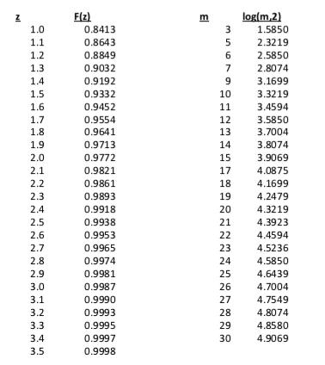

Values of the standard normal variable, useful for different LOS:  
z: 1.645 1.751 1.881 2.054 2.326

CDF F(z): 0.95 0.96 0.97 0.98 0.99

**DAIICT**

ID NUMBER: _____________________

NAME: _______________________________

**SC531 PROBABILITY & RANDOM VARIABLES**

SECOND IN-SEMESTER EXAMINATION

**QP SET B**

MARKS: 5 x 4 = 20. **Time allowed: 60 minutes**.

|  |  |  |  |  |  |
| --- | --- | --- | --- | --- | --- |
| ANSWERS | A-1 | A-2 | A-3 | A-4 | A-5 |
| Indicate parts (a) & (b), where applicable. |  |  |  |  |  |

Q-1. (a) For random variable X, it is known that the mean is 200 and the standard deviation is 10. Using Tchebycheff inequality, find an upper bound on the probability that the value of X will be outside the interval [180 ... 220].

(b) Further, it is given that random variable RV X of part (a) is normally distributed. Find the value DX such that Prob( |X-100| < DX ) = 0.95. Use the standard normal values provided.

Q-2. The following five paired values of random variables X and Y are obtained experimentally. Find the regression of Y on X.

1. values -2 -1 0 1 2

Y values 5 7 8 11 13

Q-3. Let random variable X represent vehicle arrivals per minute at a toll booth. X is assumed to be Poisson distributed with parameter l = 10. Sample arrival data is collected over 100 intervals of one minute each. Find the range [ lmin ... lmax], centred on l , such that the value of X is within that range with a probability of 95%. Use the standard normal values provided.

Q-4. (a) Random variable X has mean value 200 and standard deviation 8. For a right-tailed test of hypothesis, the level of significance (LOS) a is specified as 2%. Find the critical region of X, using the standard normal values provided.

(b) The average recovery rate for ICU patients in the country is 90%. In a given hospital, out of 400 ICU patients, 370 have recovered. At LOS = 2%, can this hospital be considered significantly better than average, for ICU patient recovery? Use the standard normal values provided.

Q-5. (a) A source is sending messages consisting of uppercase English letters, i.e. the sample space is given by S = {A, B, C … X, Y, Z}. The messages are such that these letters occur with equal probability. Find the entropy of the corresponding partition U on S.

(b) Due to a software or hardware glitch, the letters sent by the source of part (a) are getting corrupted. The corruption is such that every A becomes B, and every C becomes D. Other digits are not corrupted. Let V be the modified partition. Find the entropy of partition V.

Values of the standard normal variable, useful for different LOS:  
z: 1.645 1.751 1.881 2.054 2.326

CDF F(z): 0.95 0.96 0.97 0.98 0.99

